Digital Logic Design (DLD)
Mid Question Answer
Lecture – 1
1. What is Digital Logic Design?
Ans: The digital logic design is a system in electrical and computer engineering that uses simple numerical values to produce input and output operations. Assist in developing cell phones, computers, and related personal electronic devices.
2. How type of Numerical Representations?
Two ways of representing the numerical value of quantities: i. Analog and
ii. Digital
i. Analog Representations:
In analog representation a quantity is represented by a continuously variable, proportional indicator.
Analog = Continuous

ii. Digital Representations:
In digital representation the quantities are represented not by continuously variable indicators but by symbols called digits. As an example, consider the digital clock.
Digital = Discrete (step by step)

3. Example 1: Which of the following involve analog quantities and which involve digital quantities?
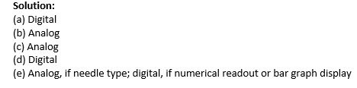
(a) Ten-position switch
(b) Current flowing from an electrical switch
(c) Temperature of a room
(d) Sand grains on the beach
(e) Automobile fuel gauge

4. Define Digital and Analog System.
Digital System: A digital system is a combination of devices designed to manipulate logical information or physical quantities that are represented in digital form

Analog System: An analog system contains devices that manipulate physical quantities that are represented in analog form.

5. Advantages of Digital Techniques.
1. Digital systems are generally easier to design.
2. Information storage is easy.
3. Accuracy and precision are easier to maintain throughout the system.
4. Operation can be programmed.
5. Digital circuits are less affected by noise.
6. More digital circuitry can be fabricated on IC chips.

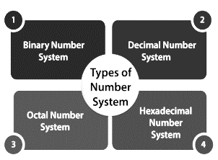
6. Type of Number System. Page (7-10)
i. Binary Number: Base 2. Carries only two digits, like that 0 or 1.
ii. Decimal Number: Base 10. Contain Ten digits, 0 to 9.
iii. Octal Number: Base 8. Contain Eight digit, 0 to 7.
iv. Hexadecimal Number: Base 16. Contain total 16 symbols like 0 to 15 (0,1,2,3,4,5,6,7,8,9, A, B, C, D, F)

7. Number Base Conversion.
Ans: Page 11-19
Lecture – 2
8. What is Binary Codes?
Ans: In the coding, when numbers, letters or words are represented by a specific group of symbols, it is said that the number, letter or word is being encoded.
9. Advantages of Binary code.
1. Binary codes are suitable for the computer applications.
2. suitable for the digital communications.
3. the analysis and designing of digital circuits much easier.
4. Since only 0 & 1 are being used, implementation becomes easy.
10. Classification of Binary Codes
• Binary Coded Decimal (BCD) Code
• Gray Code
• Excess-3 Code
• Alphanumeric Codes
• Error Detecting Codes
• Error Correcting Codes
11. Explain and Conversion BCD Code.
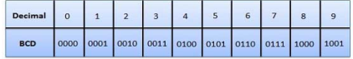
In this code each decimal digit is represented by a 4-bit binary number. BCD is a way to express each of the decimal digits with a binary code. BCD code only first ten (0000 to 1001) of these are used.

12. Advantages and Disadvantages of BCD Code.
Advantage:
• It is very similar to decimal system.
• We need to remember binary equivalent of decimal numbers 0 to 9 only.
Disadvantages:
• The addition and subtraction of BCD have different rules
• The BCD arithmetic is little more complicated.
• BCD needs a greater number of bits than binary to represent the decimal number.

13. Define Gray Code.
Ans: The Gray Code is a sequence of binary number systems, which is also known as Reflected Binary Code (RBC).
Conversion -> i. Binary to Gray code and ii. Gray to Binary code.
Ans: i. page (3-4) ii. Page (4-5)

14. Explain Gray code characteristics.
• In Gray code, two consecutive values are differed by one bit of binary digits
• Binary number is converted to Gray code to reduce the switching operation.

15. Conversion Binary to Exces-3 code.
Ans: page (7-8)

- Methods for Finding Excess-3 code of Binary Number.
Method 01:
• We find the decimal number of the given binary number.
• Then we add 3 in each digit of the decimal number.
• Now, we find the binary code of each digit of the newly generated decimal number.
Method 02:
- We can also add 0011 in each 4-bit BCD code of the decimal number for getting excess-3 code.

16. Self-Complementary Property.
Ans: Page (09)

• A self-complementary binary code is a code which is always complimented in itself. By replacing the bit 0 to 1 and 1 to 0 of a number, we find the 1's complement of the number.

• If we perform the 1's complement of excess-3 of a decimal number, it will be equal to the excess-3 code of the 9's complement of that decimal number.

17. Difference Between Unicode and ASCII
Unicode Coding Scheme | ASCII Coding Scheme
It uses variable bit encoding according to the requirement. For example, UTF- 8, UTF-16, UTF-32 | It uses 7-bit encoding. As of now, the extended form uses 8-bit encoding.
It is a standard form | It is not a standard all over the world.
People use this scheme all over the world | It has only limited characters hence, it cannot be used all over the world.
It has more than 128,000 characters. | In contrast, it has only 256 characters

Lecture – 03
18. Define De Morgan’s Theorems.
Ans: There are two basic theorems of great importance in Boolean Algebra, which are De Morgan’s First Law and De Morgan’s Second Law. These are also called De Morgan’s Theorems.

i. De Morgan’s First Law: (P.Q)' = (P)' + (Q)'
ii. De Morgan’s Second Law: (P + Q)' = (P)'. (Q)'
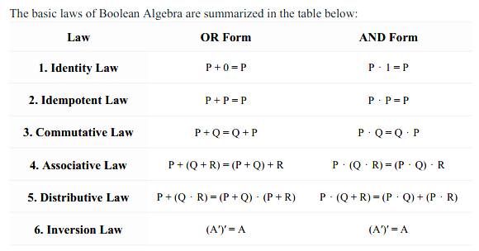
19. Applications of Boolean Algebra
- Digital Logic Design
- Algorithm Design
- Telecommunications
- Artificial Intelligence (AI)
- Electrical Engineering

20. Math page (6-10)

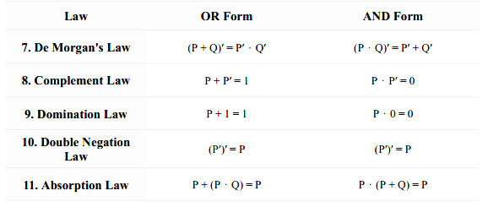

Lecture – 04
21. Advantage and Disadvantages of K-Map.
Advantages:
- Makes Logic Simpler
- Minimizes Logic Gates
- Reduce Errors
- Time-Saving
- No need for Boolean Laws
Disadvantages:
- Limited to Fewer Variables
- Not suitable for all functions
- Space Limitations
- Requires Careful Grouping

22. Math page (1-04).

Final Term
Sequential Circuits
1. Define Sequential Circuit with diagram.
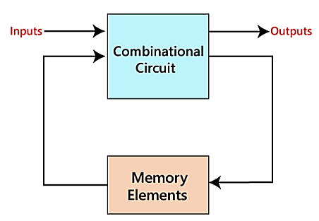
Ans: The sequential circuit is a special type of circuit that has a series of inputs and outputs. The outputs of the sequential circuits depend on both the combination of present inputs and previous outputs.

2. Combinational Circuits vs Sequential Circuits.
Ans:
Combinational Circuits | Sequential Circuits
1. The outputs of the combinational circuit depend only on the present inputs. | 1. The outputs of the sequential circuits depend on both present inputs and present state (previous output).
2. The feedback path is not present in the combinational circuit. | 2. The feedback path is present in the sequential circuits
3. In combinational circuits, memory elements are not required. | 3. In the sequential circuit, memory elements play an important role and require.
4. The clock signal is not required for combinational circuits. | 4. The clock signal is required for sequential circuits.
5. The combinational circuit is simple to design | 5. It is not simple to design a sequential circuit.

3. Define Clock Signal with diagram.
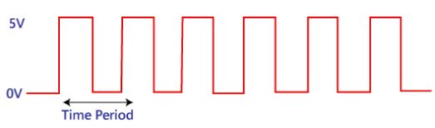
Ans: A clock signal is a periodic signal in which ON time and OFF time need not be the same. When ON time and OFF time of the clock signal are the same, a square wave is used to represent the clock signal.

4. Type of Triggering.
Ans: i. Level Triggering vi. Negative edge triggering.
ii. Positive level triggering
iii. Negative level triggering
iv. Edge triggering
v. Positive edge triggering
5. Define Latch and explain SR Latch for NAND Gate.
Ans: Latches are basic storage elements that operate with signal levels. Latches controlled by a clock transition are flip-flops. Latches are level-sensitive devices.
SR (Set-Reset) Latch – The SR latch forms the basic building blocks of all other types of flip-flops.
SR Latch is a circuit with:
(i) 2 cross-coupled NAND gate.
(ii) 2 input S for SET and R for RESET.
(iii) 2 output Q, Q’.
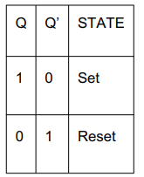
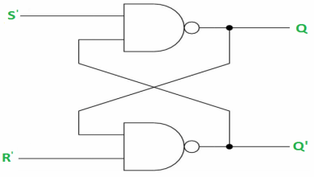
Under normal conditions, both the input remains 0. The following is the RS Latch with NAND gates:

6. Define Flip – Flop and type of flip – flop .
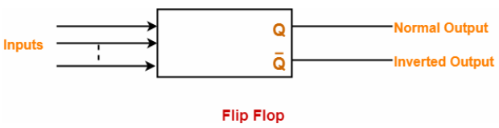
Ans: A Flip Flop is a memory element that is capable of storing one bit of information.

Type of Flip-Flop: i) SR Flip Flop ii) JK flip flop iii) D flip flop iv) T flip flop

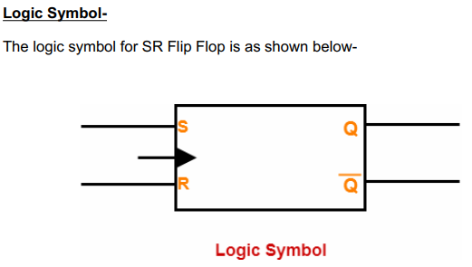
7. Explain SR Flip Flop for Nand Latch.
Ans: • SR flip flop is the simplest type of flip flops.
• It stands for Set Reset flip flop.
• It is a clocked flip flop

Construction of SR Flip Flop By Using NAND Latch -
• NAND latch
• Two NAND gates
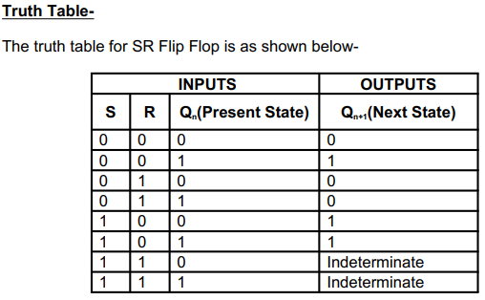
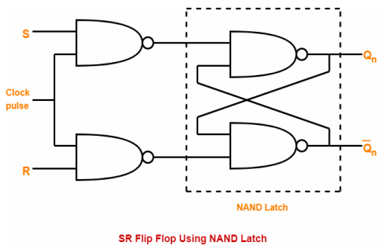
Logic Circuit:

8. Define JK Flip Flop.
Ans: JK flip flop is a refined & improved version of SR Flip Flop that has been introduced to solve the problem of indeterminate state that occurs in SR flip flop when both the inputs are 1.
9. Explain JK Flip Flop for Nand Latch.
Ans: Construction of JK Flip Flop By Using SR Flip Flop Constructed From NAND Latch –
This method of constructing JK Flip Flop uses-
• SR Flip Flop constructed from NAND latch
• Two other connections
Logic Circuit –
The logic circuit for JK Flip Flop constructed using SR Flip Flop constructed from NAND latch is as shown below-
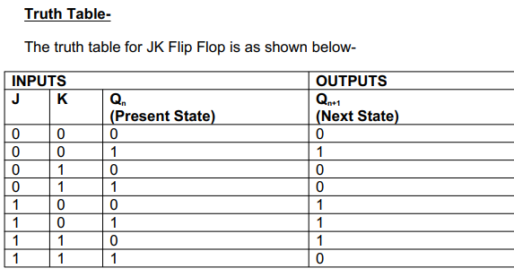
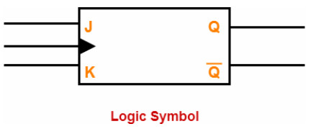
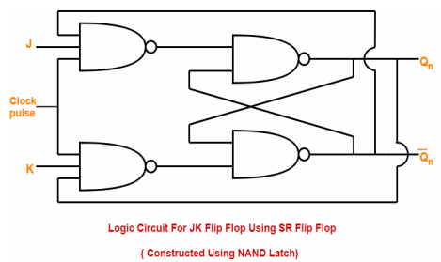

9. SR Flip Flop VS JK Flip Flop.
Ans: Both JK flip flop and SR flip flop are functionally same.
The only difference between them is-
• In JK flip flop, indeterminate state does not occur.
• In JK flip flop, instead of indeterminate state, the present state toggles.
• In other words, the present state gets inverted when both the inputs are 1.

10. Explain D Flip Flop with Circuit diagram and truth table.
The D flip flop is the most important flip flop from other clocked types. It ensures that at the same time, both the inputs, i.e., S and R, are never equal to 1.

This single data input, which is labeled as "D" used in place of the "Set" input and for the complementary "Reset" input, the inverter is used. Thus, the level sensitive D-type or D flip flop is constructed from a level-sensitive SR flip flop.

So, here S=D and R= ~D (complement of D)

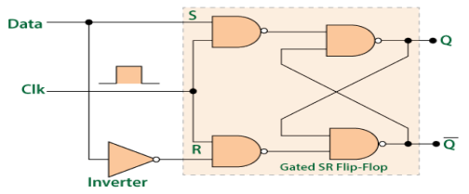
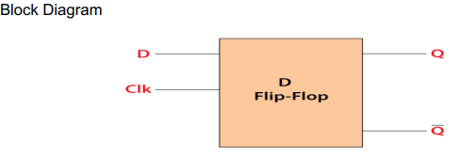
Circuit Diagram:

We know that the SR flip-flop requires two inputs, i.e., one to "SET" the output and another to "RESET" the output.
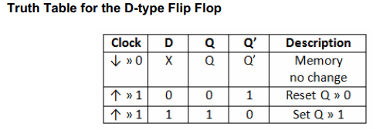
The "CLOCK" or "ENABLE" input is used to avoid this for isolating the data input from the flip flop's latching circuitry. When the clock input is set to 1, the "set" and "reset" inputs of the flip-flop are both set to 1. In simple words, the output is "latched" at either 0 or 1In simple words, the output is "latched" at either 0 or 1.

11. Explain Master – Slave JK Flip Flop with Timing diagram.
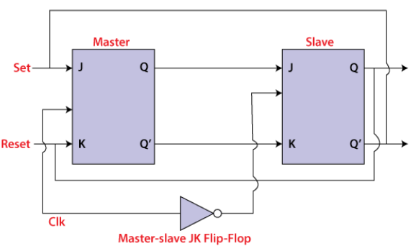
The master-slave flip flop is constructed by combining two JK flip flops. These flip flops are connected in a series configuration. In these two flip flops, the 1st flip flop work as "master", called the master flip flop, and the 2nd work as a "slave", called slave flip flop. In "master-slave flip flop", apart from these two flip flops, an inverter or NOT gate is also used.

Working process:
- When CP = 1, the master flip-flop responds to the J and K inputs, while the slave remains isolated.
- When CP changes from 1 to 0, the master stops responding and the slave receives the master's output.
- For J=1, K=0, the output is set; for J=0, K=1, the output is reset; and for J=K=1, the output toggles.
- When J=K=0, the flip-flop is disabled, so the output Q remains unchanged.
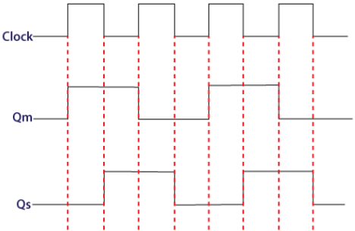
Timing Diagram of a Master Flip Flop:
- When CP = 1, the master flip-flop is active and responds to the input, while the slave flip-flop remains inactive.
- When CP = 0, the master holds its output and the slave flip-flop becomes active.
- The slave copies the master's output and provides the final output until the clock changes again.

12. Define Counter in Digital Electronics.
Ans: A counter is a digital circuit that can be used to keep track of the number of events or clock cycles that have occurred.
i. Binary Counter ii. Decade/ Decimal counter iii. Up/Down counter
13. Define Register in Digital Electronics.
Ans: A register in digital electronics is a group of flip-flops that can be used to store binary data. Registers are often used to hold intermediate results in digital systems

PDF – 8
Half, Full Adder, Ring and Johnson Counter
14. Explain Half Adder with diagram.
Ans: A half adder is a basic combinational circuit that adds two single-bit binary inputs (A and B) to produce a SUM using an XOR gate and a CARRY using an AND gate, without considering any carry-in from a previous stage.
- Performs binary addition of two single-bit inputs, generating a SUM (A ⊕ B) and CARRY (A · B)
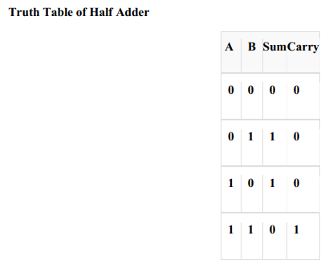
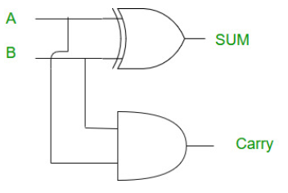

15. Half Adder Advantages and Disadvantages and Application.
Application:
- Binary Addition
- Building Block for Full Adders
- Digital Arithmetic Circuits
Disadvantages:
- No Carry Input
- Limited Functionality
- Requires Full Adders
Advantages:
- Simple Design
- Fast Operation
- Low Hardware Requirement

16. Explain Full Adder with Circuits Diagram.
Ans: Full Adder is a combinational circuit that adds three inputs and produces two outputs. The first two inputs are A and B and the third input is an input carry as C-IN. The output carry is designated as C-OUT and the normal output is designated as S which is SUM.
Logic Circuit of Full Adder
To implement a Full Adder using basic logic gates:
Sum (S) is implemented using XOR gates:
Use two XOR gates:
• First XOR gate: A ⊕ B
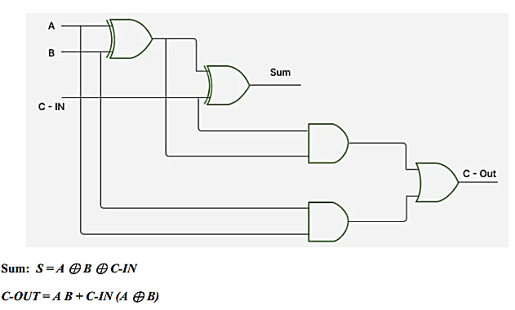
• Second XOR gate: (A ⊕ B) ⊕ C-IN to get the final sum S
N.B : দুইটা Half Adder দিয়ে একটা Full Adder create করা
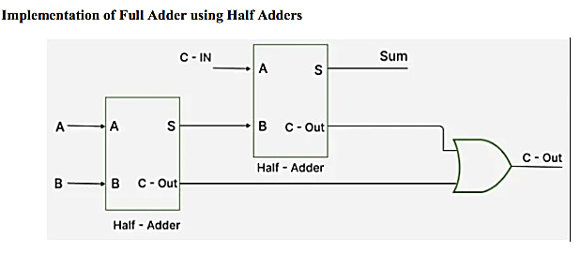

17. Define Ring Counter.
Ans: A ring counter is a typical application of the Shift register. the last flip-flop is connected to the input of the first flipflop in the case of the ring counter.
No. of states in Ring counter = No. of flip-flop used
18. 3, 4, 5 bit Ring Counter Example with diagram and working process.
Ans: Let’s consider a 4-bit Ring Counter:
1. Initial state : 1000
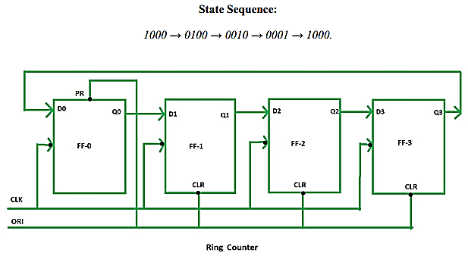
2. Clock Cycle 1: The 1 bit shifts to the next flip-flop, resulting in the state 0100.
3. Clock Cycle 2: state 0010.
4. Clock Cycle 3: state 0001.
5. Clock Cycle 4: state 1000.

Working Process:
- A Ring Counter is typically built using flip-flops (D, T, or JK flip-flops)
- A Ring Counter uses n flip-flops, where one flip-flop is set to 1 and the others are set to 0.
- On each clock pulse, the 1 bit shifts from one flip-flop to the next.
- The output of the last flip-flop is fed back to the first, creating a continuous repeating sequence.
19. Ring Counter Advantages and Disadvantages and Application.
Applications:
- Sequence Generation
- Control Systems
- Simple Design
- Finite State Machines (FSM)
- Shift Register Based Applications
Disadvantages:
- Limited States
- Not for Complex Patterns
- Needs Initialization
- Hardware Cost Increases
Advantages:
- Simplicity
- Low Resource Use
- Predictable Output
- Easy to Decode
- Glitch-Free Output

20. Explain n-bit Johnson Counter.
JA Johnson counter, also known as a twisted ring or creeping counter, is a synchronous shift register counter. It uses n flipflops to generate 2n unique states.
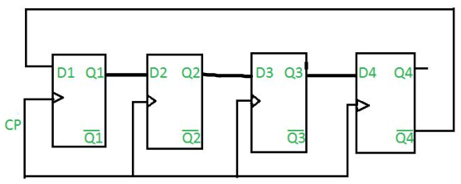
Total number of used and unused states in n-bit Johnson counter:
number of used states=2n
number of unused states=2^{n} - 2*n
Example:
If n=4
4-bit Johnson counter:
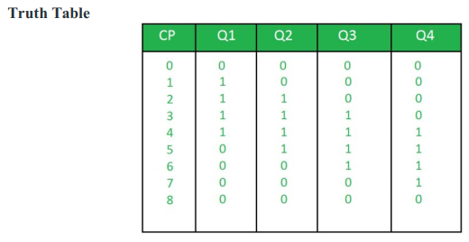

21. Ring Counter VS Johnson Counter.
Ring Counter | Johnson Counter
A ring counter employs the carry-in of the last flip-flop into the input of the first flipflop without any manipulation. | In Johnson counter, the complement of output of the last flip-flop is applied to the input of the first flip-flop.
n' flip-flops are required to count 'n' states. | 'n' flip-flops are required to count '2n' states.
It can Generate 'n' unique states | It can Generate '2n' unique states
Unused states None, because all the states are utilized | '2n-2n' states are unused
Its not self-decoding since additional circuitry is needed | Its self-decoding makes it simpler for certain applications
Since it does not require inversion feedback | Due to inversion, the circuit is slightly more complex

